**DAILY ONLINE ACTIVITIES SUMMARY**

|  |  |  |  |  |  |
| --- | --- | --- | --- | --- | --- |
| **Date:** | **5-06-2020** | | **Name:** | **Shah Dhruvil Amit** | |
| **Sem & Sec** | **6th - B** | | **USN:** | **4AL17CS083** | |
| **Online Test Summary** | | | | | |
| **Subject** | **OPERATION RESEARCH** | | | | |
| **Max. Marks** | **30** | **Score** | | **30** | |
| **Certification Course Summary** | | | | | |
| **Course** | **Python programming** | | | | |
| **Certificate Provider** | **E-box** | **Duration** | | | **2 hours** |
| **Coding Challenges** | | | | | |
|  | | | | | |
| **Status: executed** | | | | | |
| **Uploaded the report in GitHub** | | **Yes** | | | |
| **If yes Repository name** | | <https://github.com/DhruvilShah99/Daily-Updates> | | | |
| **Uploaded the report in slack** | | **Yes** | | | |

OR IA -3

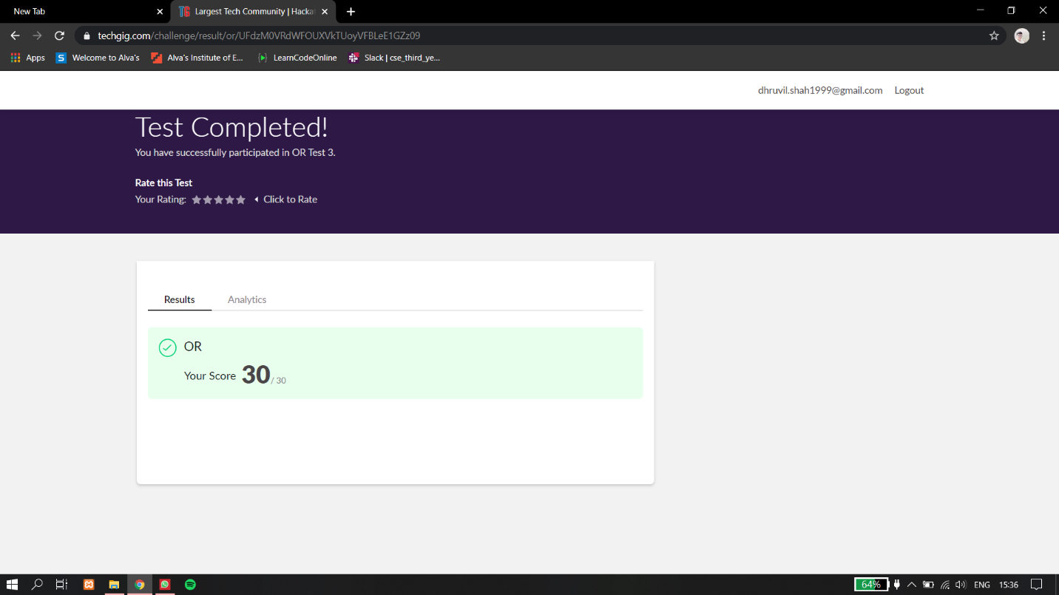

Certification Course Details:

Report

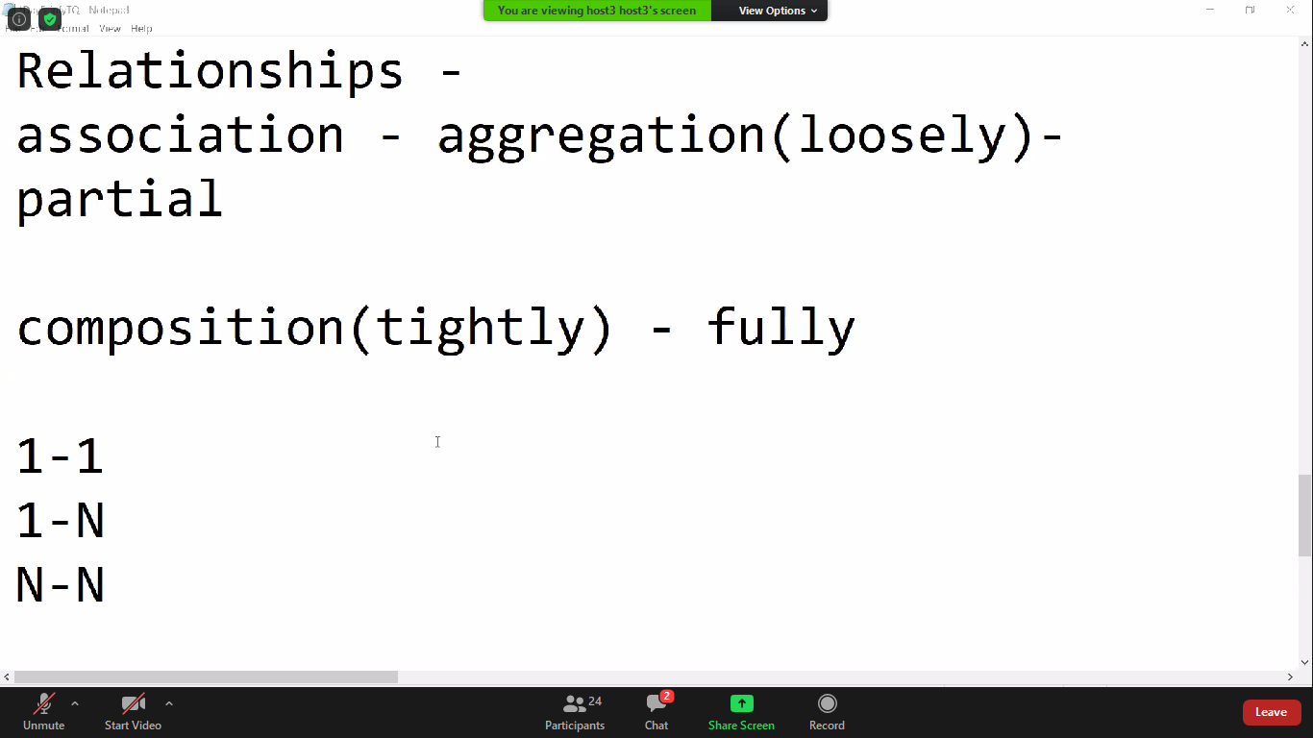

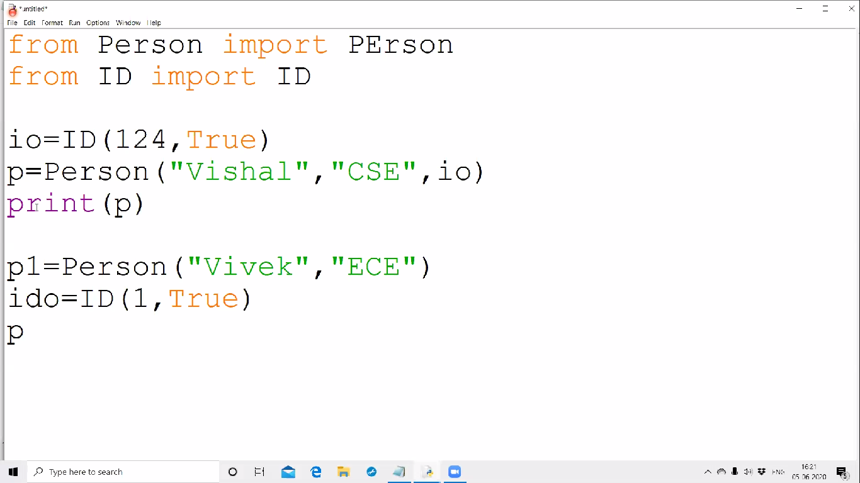

In today online certification session, I have learnt to about relationships where aggregations and association type has been taught. Even 1 to 1, 1 to n and n to n functions were explained with examples.

Coding Challenges Details:

The below GitHub link for details

<https://github.com/DhruvilShah99/Daily-Updates>

P-1

**Python program to square only odd number from list**

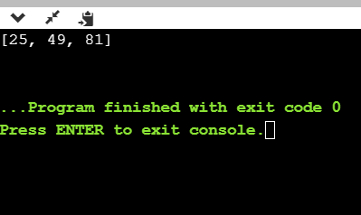

**P-2**

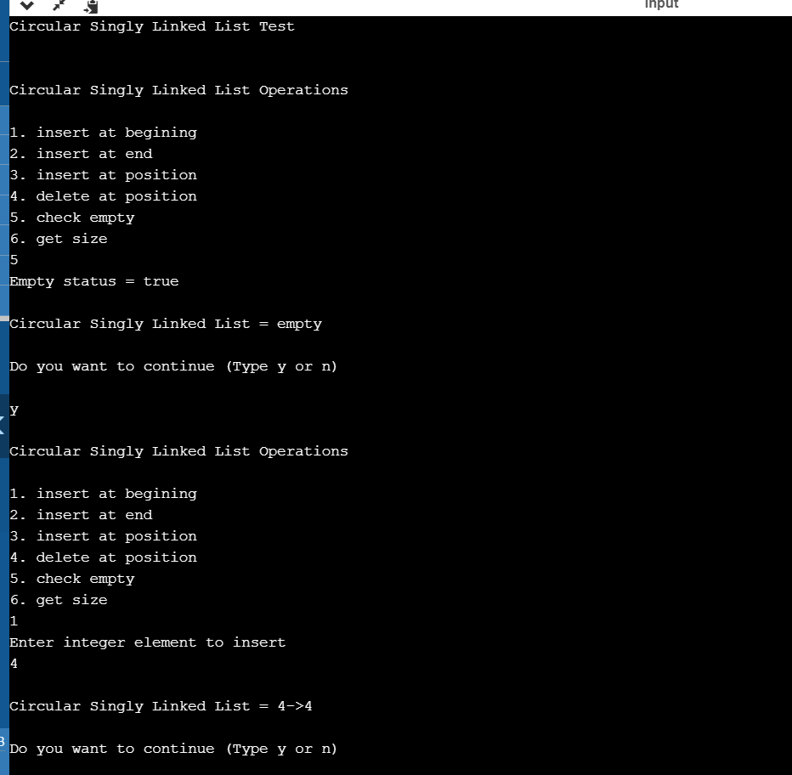

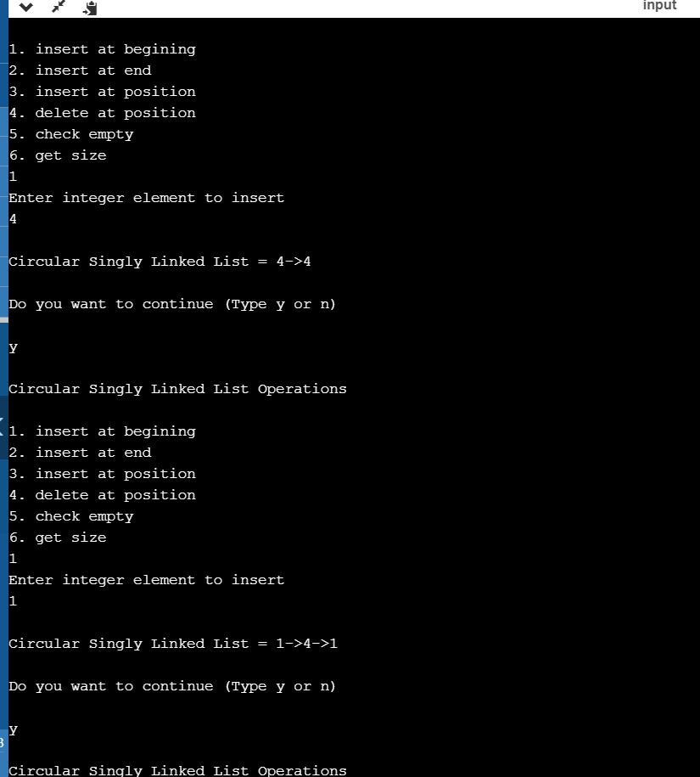

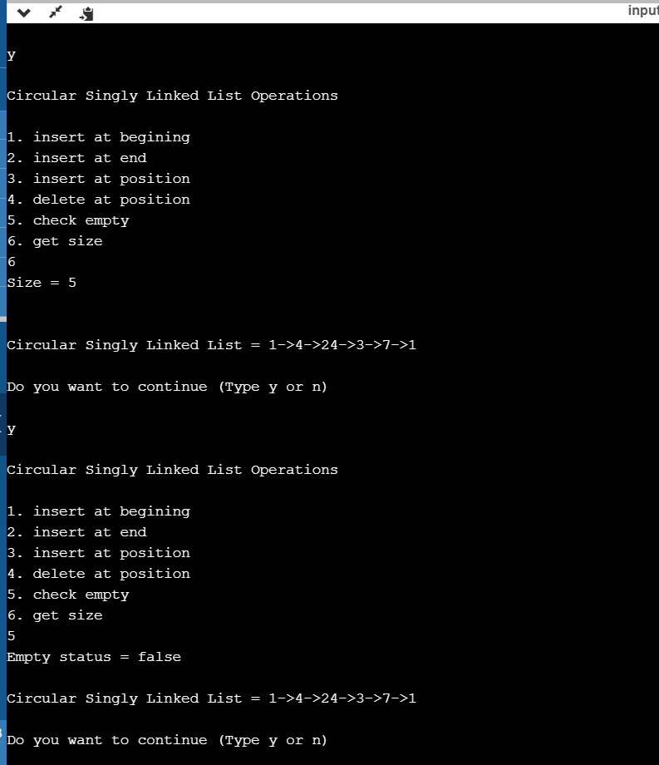

**Java program to implement Circular linked list using Array and Class.**